Experiment Plans for Intelligent Traffic Management System

Environment Setup
The experiment will be conducted in the campus car park. We will place sensors on each of the road around the parking spaces as shown in the diagram below. The car will be circling the car park space and pass each of the sensor node.
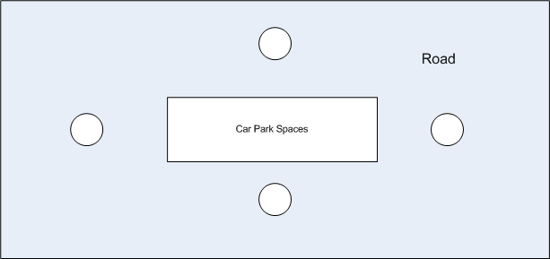

Phase I - Vehicle Detection Testing
Let one or two cars driving along the road with different speed. For each sensor, when it detects a car, it will send a message to the next sensor. It will also record and report the event when a car reaches or leaves. During the testing, we may set the sampling rate of each sensor to be a little bit high (say 200 Hz, the exact value will be determined by some indoor experiments). Based on the testing results with high sampling rate, we may derive the results with lower sampling rate.
The output of this testing is:
- The accuracy of the detection. (How many correct events are detected? How many false events?)
- Among all of the correct detections, how many messages are successfully transmitted to the next sensor (i.e. the packet loss)?

Phase II - Speed Measurement Testing

